Cloud Computing – Session 6
Advance S3 and Glacier

ASSIGNMENT - 1

SUBMITTED BY:
Mahendra M. Sunar

DATE: 13th July, 2017
Hosting a static website
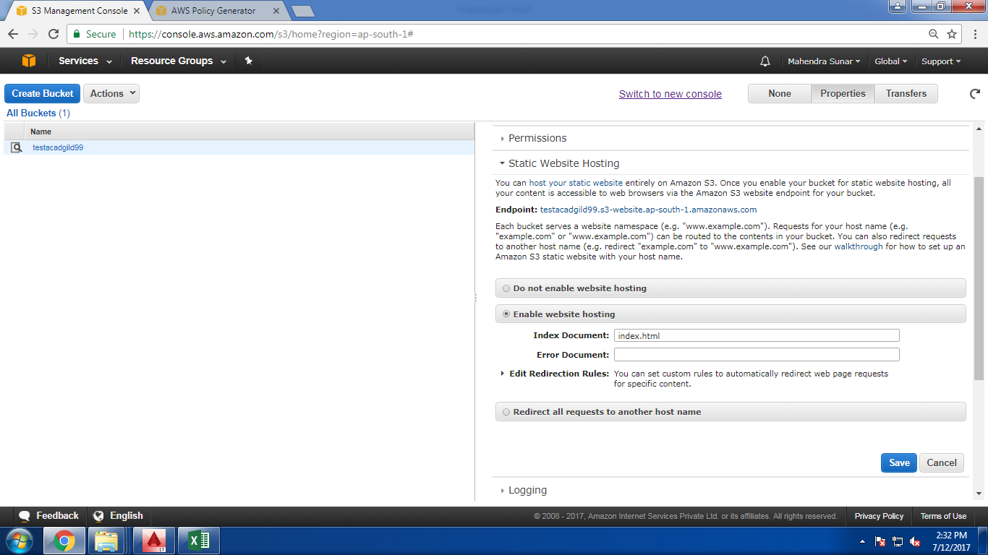

Setting permission for Static Website
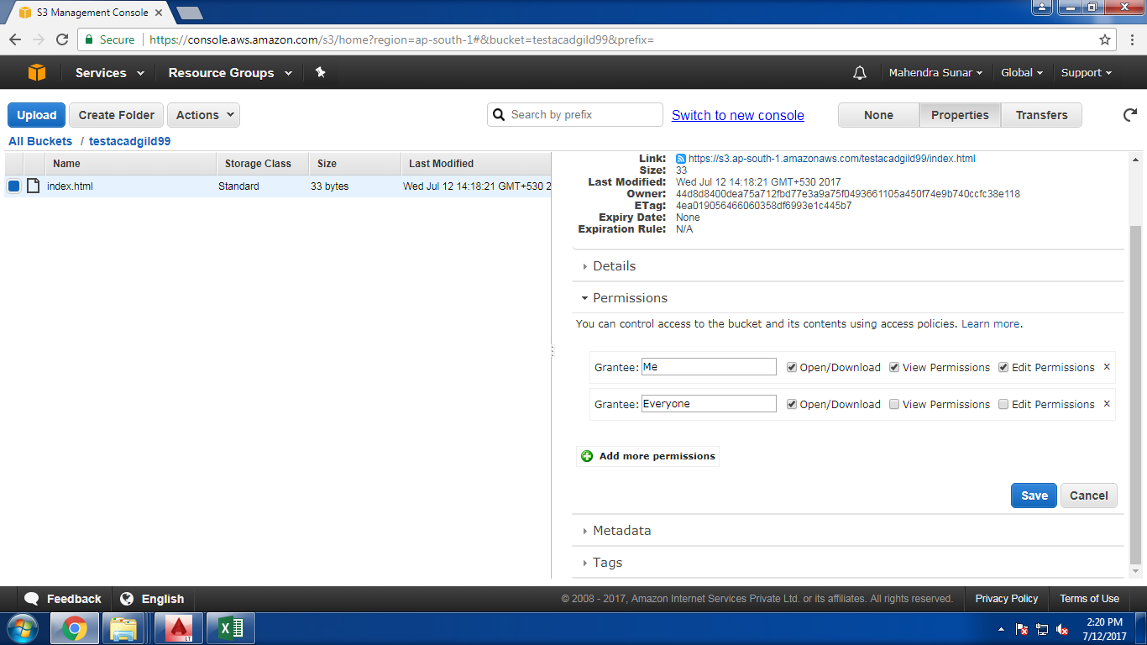
Endpoint URL for Static Website: http://testacadgild99.s3-website.ap-south-1.amazonaws.com/
